Exp No. Date:
Design, Fabrication and Verification of PCB for Transistor as a Switch
Aim: To design and fabricate of PCB for Transistor as a Switch and verify its operation.
Apparatus:
S. No | Name of the Equipment/Component | Quantity
1 | BC107/NPN transistor | 1 No.
2 | Resistor | 2 No
3 | LED | 1 No
4 | Copper cladded board | 1 No.
5 | Ferric Chloride Solution, Thinner | -
6 | OHP Sheet, Iron box | -
7 | Signal generator | 1 No.
8 | Cathode Ray Oscilloscope (CRO) | 1 No.
9 | Connecting wires and probes | -
Theory:
A transistor can function as an electronic switch by operating it in its cutoff and saturation regions. In this configuration, the transistor either completely blocks current (OFF state) or allows maximum current flow (ON state). For an NPN transistor such as the BC107, when the base-emitter junction is not forward biased (base voltage near 0 V), the transistor remains in the cutoff region, and no current flows from the collector to the emitter. This keeps the load, such as an LED, turned OFF. When a sufficient positive voltage (typically around 0.7 V or higher) is applied to the base with respect to the emitter through a base resistor, the transistor enters saturation. In this state, the collector-emitter path acts like a closed switch, allowing current to flow through the load connected at the collector. The LED in the circuit then glows, indicating the ON state.
Procedure:
Design and fabricate the PCB as per procedure mentioned below
Step I. PCB Design Using EAGLE Software
- Install EAGLE software (select freeware mode during installation).
- Open the software → File → New → Project → Rename (e.g., test_0).
- Right-click on the project → New → Schematic.
- Maximize schematic editor window → View → Grid → Enable grid settings.
- Click Add to place components (e.g., resistor, diode 1N4004, connectors).
- Use Move, Mirror, Rotate tools to arrange components properly.
- Use Net tool to make electrical connections in the schematic.
- Go to File → Switch to Board to generate board layout.
- In the board window, arrange components optimally.
- Run DRC (Design Rule Check) → Edit parameters → Apply and Select.
- Click Auto-Router → Fill required info → Start → End Job.
- Click Print → Adjust settings → Save output as PDF.
Step II. Toner Transfer and Board Preparation
- Print the board layout PDF on an OHP sheet (toner side).
- Cut both the layout and the copper board to desired size.
- Clean copper surface with steel wool and detergent.
- Place the printed layout (toner side down) on the copper board.
- Iron the layout onto the board for ~10 minutes using firm, even pressure.
- Soak the board in warm water and peel off the sheet carefully.
Step III. Etching Process
- Prepare a ferric chloride solution in a plastic tray.
- Immerse the board into the solution (at ~60°C) until unwanted copper dissolves.
- Rinse the board with clean water.
- Remove residual toner using acetone and cotton.
Step IV. Drilling
- Drill holes at the marked component pads using a mini drill.
- Ensure holes are clean and correctly aligned.
Step V. Component Mounting and Soldering
- Insert electronic components (resistors, diodes, etc.) into the board.
- Bend leads on the backside to hold components in place.
- Solder each joint using a soldering iron at ~350–400°C.
- Trim excess leads with a cutter.
- Inspect solder joints for quality (shiny and conical shape).
- Clean board if needed and test connectivity.
Step VI.
- Make sure all components on the PCB are properly soldered and connected as per the circuit design.
- Connect a DC power supply with a biasing voltage of 12V to the collector terminal, ensuring correct polarity.
- Connect another DC power supply to the input terminal. Initially, set the input voltage to 0V and verify that the output LED remains OFF. Then, increase the input voltage to 5V and observe that the output LED turns ON.
Schematic:
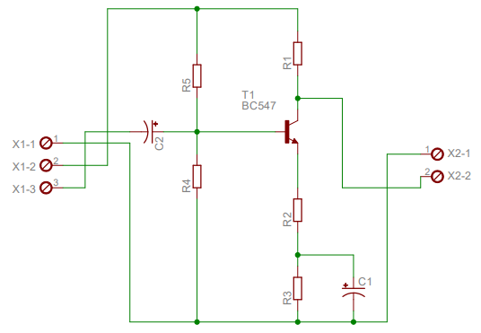

Board with Names:
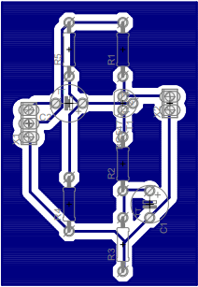
Board Layout:
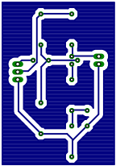

Model Waveforms:

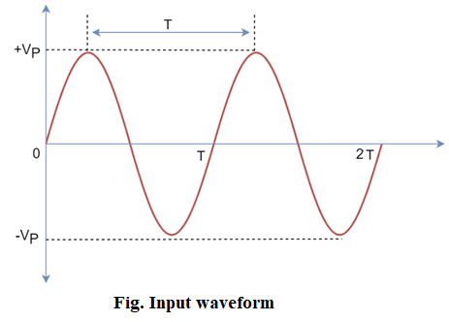

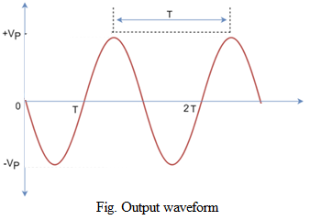

Result:

